CLAM AV:

Using nClam is very easy. It has one pre-requisite, a ClamAV server. In the past, ClamAV was difficult to get running on Windows, but the team has done a lot of work on the Windows version and it’s able to install as a Windows Service right out of the box now. Here are some quick steps to installing ClamAV:

* Download the 32-bit or x64 version of ClamAV here: <http://oss.netfarm.it/clamav/>.
* Extract the ClamAV binaries to C:\\clamav
* Create an empty folder called DB in C:\\clamav  
  [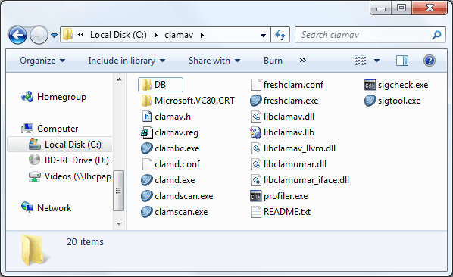](https://www.architectryan.com/static/image-0ceac9de5e564fddef63dc185217a39d-157a6.png)
* From a command prompt in C:\\clamav, run freshclam.exe (this will download the latest virus definitions)  
  [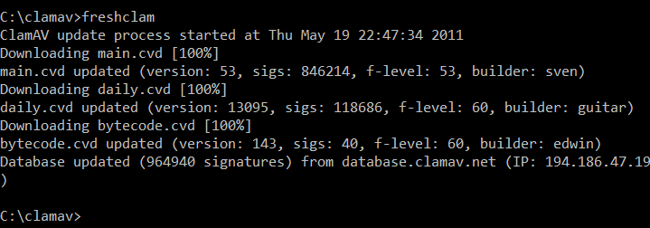](https://www.architectryan.com/static/image1-8341a53a5083e1272600e9269684ff43-a86a9.png)
* Install the ClamAV service by running: clamd --install[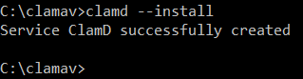](https://www.architectryan.com/static/image2-f15779fe8b541e2c839d0de530bf4c17-32c6f.png)
* Install the ClamAV Virus Updater service by running: freshclam --install[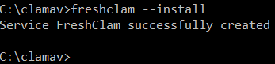](https://www.architectryan.com/static/image3-58e58d5edf3a7fdb4106639c3eeb699c-17453.png)
* Open up the Windows Services list and set the “ClamWin Free Antivirus Scanner Service” and the “ClamWin Free Antivirus Database Updater” to Startup Type: Automatic and start them.  
  [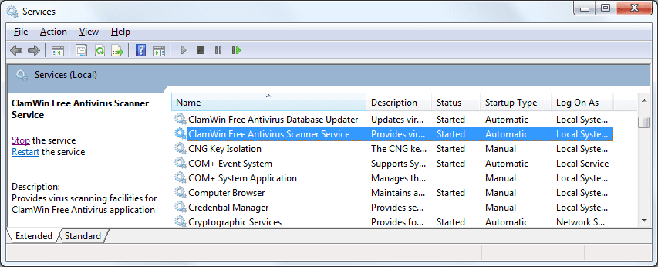](https://www.architectryan.com/static/image4-d7269dfc1f522a8cb938447b0d116d7b-9d28e.png)
* The ClamAV Server is now set up!

Whitelist the path storing the file. So that the Windows Defender does not interfere.

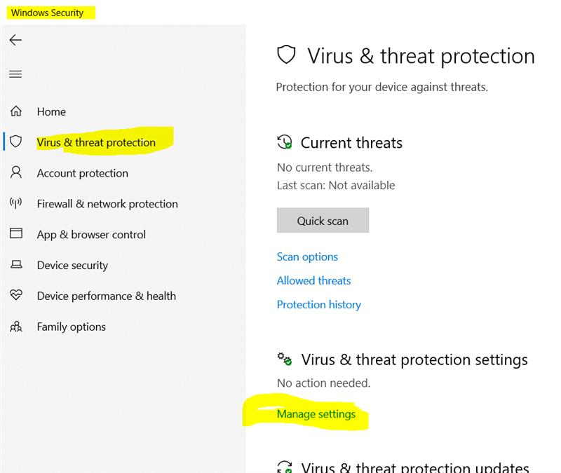

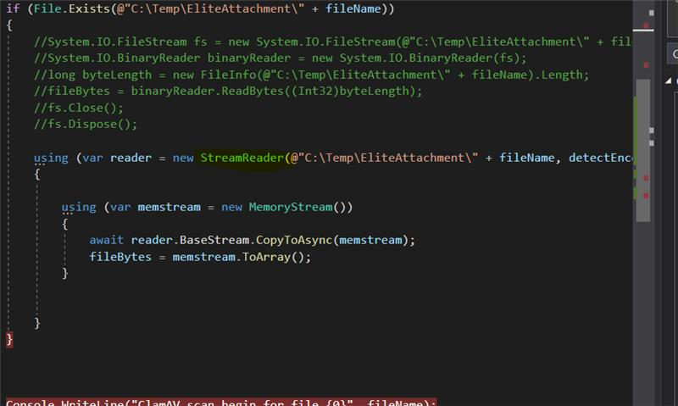

Use Stream Reader instead of FileReader as FileReader has Virus Scan method implicitly added.

